Data Analytics Bootcamp 12 June 12, 2021

Tecnologico de Monterrey

ETL- Project Report

Housing loans Analysis for Mexican Municipalities.

To achieve the objective for the project the following steps were taken:

Extraction

1. Data was acquired from two different CSV sources from INEGI (Instituto Nacional de Estadística y Geografía) and SNIIV (Sistema Nacional de Información e Indicadores de Vivienda).

Sources:[1]

https://www.inegi.org.mx/programas/ccpv/2020/default.html#Datos_abiertos

https://sniiv.conavi.gob.mx/reportes/datos_abiertos.aspx

1. Concatenate elements from both data sets were chosen for their similarities
   1. “Clave de Entidad”
   2. “Clave de Municipio”

Transformation

1. SQL
   1. Staging 1:

Concatenation of Datasets.

Generation of foreign keys: Entidad and Municipio from INEGI Dataset.

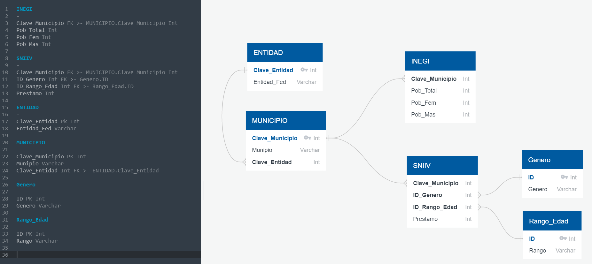

* 1. Staging2

1. Jupyter Notebook

Loading

1. Link the files can be found in ReadMe.md File.